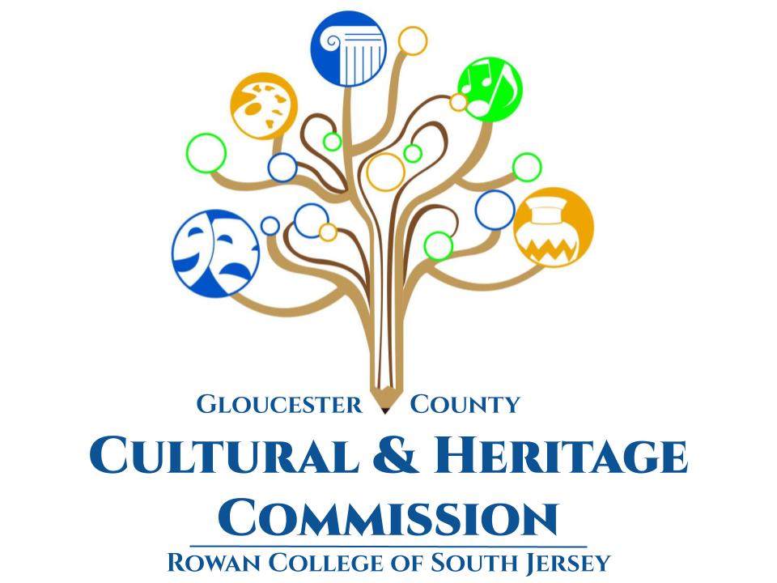

**Gloucester County**

**Cultural & Heritage Commission**

**Arts & Humanities Council of Rowan College of South Jersey**



**gloucester county cultural & heritage commission**

**rowan college of south jersey**

**ATTN: Erika Gardner**

**1400 Tanyard RD.**

**Sewell, NJ 08080**

**phone: 856-562-7538**

[**egardner@rcsj.edu**](mailto:egardner@rcsj.edu)

**Gloucester County Cultural & Heritage Commission**

**Rowan College of South Jersey**

**Commissioners**

**Harry Schaeffer, *historian*, *Chairperson***

**Eoin Kinnarney, *Vice Chairperson***

**Jessica Ferguson, *History Consultant***

**Dr. Ross Beitzel**

**Gregory M. Murphy**

**Diane MacWilliams**

**Marcela Savelski**

**Kerri Sullivan**

**Dr. Gina Mateka**

**Danielle Scott**

**Jim O’Connor**

**Richard Hughes**

**Staff**

**Erika Gardner**

**Administrator of Cultural & Heritage Affairs**

**This application is available in Microsoft Word on the Gloucester County Cultural & Heritage Page of the RCSJ Website and by request at:** [**egardner@rcsj.edu**](mailto:egardner@rcsj.edu)

***Note: Applications consisting of one (1) original, one (1) digital copy and all required support materials must be delivered to Erika Gardner at the Gloucester County Cultural & Heritage Commission on or before November 7, 2025***

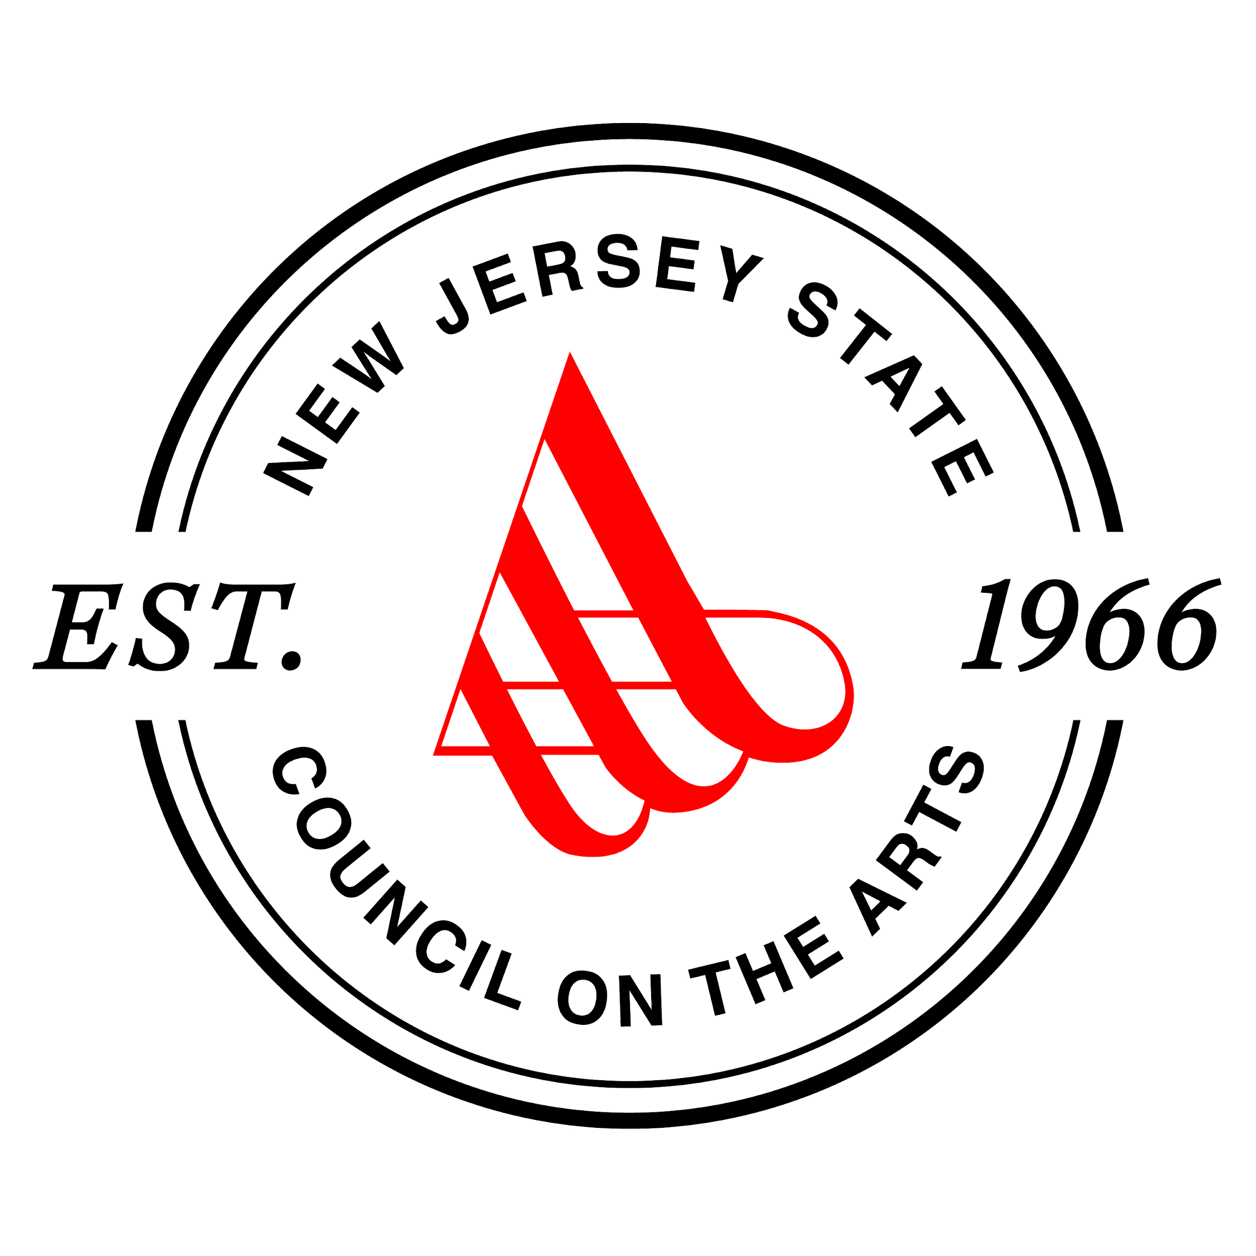

**Made possible by funds from the**

**New Jersey State Council on the Arts, a partner**

**agency of the National Endowment for the Arts.**

**Gloucester County Cultural & Heritage Commission**

**New Jersey State Council on the Arts**

**Re-Grant Program**

***Table of Contents***

**Guidelines**

* Introduction Page 4
* Categories of Funding Page 5
* Eligibility Page 5
* Ineligible Expenses Page 6
* Funding Level Page 6
* Matching Requirements Page 6
* Attachments Page 7
* Deadline for Applications Page 7
* Cultural & Discipline Codes Page 7
* Review Process Page 7
* Appeal Procedure Page 8
* Awards Page 8
* funding Page 9
* Acknowledgement Page 10

**Appendix**

* ada planning guidepage 11

**Guidelines**

**Introduction**

Thank you for your interest in the Gloucester County Cultural & Heritage Commission’s re-granting program. The charter of the Commission is clearly defined in its name: it is the organization charged by the county to recommend and administer programs to increase the visibility and impact of local and county history, arts, cultural values, goals and traditions of the community. It serves as the designated agency by the Board of Chosen Freeholders to seek available State and Federal funds to develop and support cultural and heritage programs.

The Commission administers Local Arts Program (LAP) funding provided by the New Jersey State Council on the Arts (NJSCA). NJSCA reviews the applications for LAP funding and based on the perceived quality of the proposed programming and the anticipated value to the community, they allocate funds from their annual budgets to the County. Using the same criteria, the Commission then re-grants some or all of the funding to individual group applicants for implementation of their programs.

Should you have any questions as you are working on this application, contact Erika Gardner at 856-464-5214, [egardner@rcsj.edu](mailto:egardner@rcsj.edu).

The New Jersey State Council on the Arts is the State agency charged with promoting interest in arts programs throughout the state. A portion of NJSCA’s funding may come from the National Endowment for the Arts, and it is important to keep in mind that proposals submitted to the Commission and by the Commission must comply with guidelines established by all funding entities. It is therefore imperative that all information requested be supplied. Failure to do so will result in disqualification.

Please note that all applicants must complete the ADA checklist and include a board approved ADA Plan.

**** **Long Range Plans** are only required for General Operating Support Grants. Because Long Range Planning is a requirement since 2017, General Operating Support grant applications should reflect in the narrative how the organization is working towards an agency plan. The Long Range Plan will then be required from the award recipients with their Final Report.

These documents are essential parts of your application.

**Categories of Funding**

There are two categories of funding under the Commission’s re-grant program. Applicants may apply in only one category annually.

**Special Project (SP):** Funding is for any nonprofit group, regardless of the intent of its charter, to sponsor a special arts project. This Special Project funding is intended to allow, for example, a civic organization to incorporate the arts into its economic development promotions, a social service organization to develop an arts enrichment program for young people, or a library to sponsor a special exhibition.

**General Operating Support (GOS):** This funding is for groups whose charter is primarily arts related. It is designed to provide general operating support for groups that increase exposure to art in the community. This would include, but is not limited to: community theater groups, dance companies, not-for-profit museums or galleries, orchestras, and vocal groups who exist primarily to create and/or perform arts programs. General Operating Support funding is more stringent in its requirements and more detail is required in substantiating fiscal responsibility. **General Operating Support requests are limited to 20% or less of the previous year’s cash income.**

**All applicants must complete the application checklist, signature page and ADA Checklist. You should complete the Narrative and Budget Forms pertaining to the category of funding you are requesting.**

**Eligibility**

* Any non-profit group is eligible, including libraries, civic organizations, Y’s, educational institutions (for non-standard extracurricular funding only), museums, historical groups, festival programs, arts councils and commissions, and creative groups in all disciplines. **Non-arts groups can apply for Special Project Grants but only to support arts-related projects. Non-arts groups must show a prior history of arts programming for at least two years.** Any proposal that does not clearly support the arts, no matter how well prepared, will be denied funding.
* Arts as used in these guidelines includes: visual arts (painting, sculpture, drawing, etc.), music, dance, theater, opera/music theatre, crafts, media arts, photography, design arts, folk/traditional arts and literature. The Commission is open to other kinds of arts programming, but strongly recommends that you discuss the suitability of your project with the GCC&H Administrator before beginning work on a proposal.
* The State Council on the Arts does not permit county agencies to award fellowships. Individual artists should apply directly to the NJSCA.
* All proposed projects must take place within Gloucester County.
* Projects must commence no sooner than January 1, 2026 and must be completed on or before December 31, 2026 for compliance with the NJSCA grant cycle.

**Ineligible Expenses**

* Capital expenses or equipment needs. Any material with a three years or longer life expectancy (i.e. **photocopier, fax machine, a/v equipment, equipment leases, musical instruments, real estate, building repairs or improvements, etc.) are considered capital expenses for the purposes of this grant.**

*Note: Reusable materials such as theater sets, exhibition supplies or sheet music are not considered capital expenditures.*

* Deficit reduction or for the replacement of funds normally budgeted for the agency’s activities.
* Fundraising events or components of fundraising events; income from such events, however, can be included as part of the applicant’s matching funds.
* Hospitality. Food, beverage and related expenses for entertaining; these expenses, however, can be shown as part of the applicant’s matching funds.
* Expenses incurred prior to the grant period.
* Scholarships and Fellowships.
* Projects in educational and/or religious institutions that do not actively seek a wide general public audience.

**Funding Level**

***There are no set limits on the amount of funding that may be requested***. However, it is important to understand that grants are competitive, and the final awards are based on artistic merit, documentation of past arts programming, financial and administrative capability, the quality of the project, and prior funding histories, if available. The completeness and correctness of the application submitted to the Commission will also be a factor in award considerations.

Given the limited grant resources available applicants must use good judgment when completing the budget information and should submit budgets that accurately reflect their needs. Inflated budgets will be flagged, and may adversely affect funding decisions at all levels of review. Although the Commission often has more requests than funds, every effort is made to award appropriate funding. It is not our intent to restrict your vision, but rather to encourage fiscal responsibility.

**Matching Requirements**

Each organization is encouraged but not required to match the funding requested from the GCC&H’s LAP Grant program on a 1:1 basis (colleges and universities , however, must match on a 2:1 ratio). That is, for each dollar you request, you must be able to provide a dollar from other funding sources. Cash sources may include other government agencies (excluding the Commission, NJSCA or other county cultural and heritage agencies), private contributions, membership fees, admission to programs, other grants, organization cash resources, etc. Salaries and benefits for organizational employees may be considered as cash match for the part of their job that is related to the project in question. **Additional in-kind donations may count towards your optional match.**

**Attachments**

Required attachments are specified according to the type of grant on the application checklist.

**Deadline**

Applications consisting of **one** **(1) original and one (1) digital copy** of the application and all support materials must be delivered to Erika Gardner at the Gloucester County Cultural & Heritage Commission on or before **November 7, 2025.**

**Cultural & Discipline Codes**

The following codes are required by NJSCA and must be specified on the signature page of your grant application. The Cultural Code that applies is the one that best represents the predominant composition of your board and/or staff. If the program itself is targeted at a special constituency to promote cultural diversity then it must be noted in the narrative.

***Cultural Codes:* A** Asian **B** African-American

**H** Hispanic **N** Native American / Alaska Native

**W** White, not Hispanic **P** Native Hawaiian / Pacific Islander

**G** General (no single race represents more than 50%)

***Discipline Codes:* 01** Dance **08** Photography

**02** Music **09** Media/Arts

**03** Opera, Musical Theatre **10** Literature

**04** Theatre **11** Interdisciplinary

**05** Visual Arts **12** Folk Arts

**06** Design Arts **14** Multidisciplinary

**07** Crafts **17** Presenters

**Review Process**

At the beginning of each grant cycle, a Grant Writing Workshop is held to provide applicant organizations the opportunity to meet with staff, review the requirements for the proposal, and ask questions. All organizations planning to submit a proposal are encouraged to send a representative to the meeting, preferably the person responsible for organizing the proposal and writing the narrative.

Once the final submittal is made, staff reviews the applications and prepares review packets for the Grants Review Panel. An independent panel of arts and history professionals carefully reviews all applications received for the grant cycle. The proposals are evaluated for artistic merit, the manner in which the proposals address the needs of the community and the NJ Arts Plan Goals, compliance with local, state and federal law, the applicant’s administrative capabilities and prior program and funding history, where available.

**The panel will make recommendations and provide scores to the Commission based on the following criteria:**

1. **Quality of Art, Education or Creative Experience**: Does the project, program or institution have a system or plan to ensure the highest quality to the work being conducted? Is the organization listening to numerous interests and points of perspective? Is the work or organization engaging and thought-provoking? How innovative is the concept?
2. **Audience Engagement**: Audiences seek experiences that are active, immersive and even social. How well does the organization understand and know its audience? Is the activity participatory or have a participatory component? Is there a learning component? Is the experience more than a singular event and include ways of continuing interaction and impact?
3. **Attendance/Quantitative Impact**: How many individuals this programming will engage in some way? Are there plans to reach as many people as possible? Is the marketing inclusive (i.e. are there efforts to reach a diverse audience)?
4. **Governance:** Does the organization have a track record of good programming administration? Is the governance (both staff and board) diverse and inclusive? Is the governance representative of the community being served? Are high standards of professional conduct in place? Does the program or institution conduct critical assessment to determine success and impact?
5. **Budget:** Does the organization seem to have a realistic grasp of the programming costs? Is the organization working to diversify funding sources across government, foundation, business and audience/member giving? Is efficiency a consideration in programming goals?

The panel will make recommendations to the Commission regarding which proposals should be funded and at what level. The Commission reviews the recommendations and submits their report to the RCGC Board of Trustees for final approval. At any point in this process questions may be referred back to the review panel.

**Appeal Procedure**

Applicants may appeal the decision of the Commission upon receipt of the Panel’s determination letter. **Please note: Appeals can be made only on the grounds that the application was misinterpreted or misunderstood. No appeal will be heard based solely on disagreements with the recommended funding level.** No new information will be accepted for consideration and additional segments cannot be added to increase the funding. **Applicants will have two weeks from receipt of the determination letter to file an appeal with the Commission.**

**Awards**

Awards will be made by mailed letter in December. Groups should not begin projects dependent on GCC&H funds until they have received official notification of the award amount.

**Funding**

Grant funds are distributed in two payments. The first payment will be made after the terms and specifications of the award are met and contracts are signed. This process includes notification of the final amount of the award. If there were reductions in funding at this time you will be required to submit a revised budget reflecting the actual grant award. The first payment is 75% of the full award amount. Please note that no payments are processed until the contract has been correctly completed and submitted and all necessary payment vouchers are returned.

The final payment of 25% is made *after* the Final Report is submitted. Final Reports may be submitted after the project is completed, but no later than **December 31, 2026**. Receipt of the final payment is dependent on several factors:

1. Programs must be completed and funds utilized in strict compliance with the plans outlined in the proposal;
2. Any changes in the program must be discussed with Commission staff *prior* to implementation and must be reported in the Final Report;
3. A short interim report is required to update the commission on program progress;
4. A Final Report must be on file at the Commission office;
5. The Commission and the New Jersey State Council on the Arts must have been properly credited in all advertising and print and on-line materials;
6. The organization must have provided and documented the required matching funds.

All or part of the final payment may be withheld if the above conditions are not met, or if other requirements that may be stipulated by the Commission or NJSCA during the contract period are not met. The extent of the monies that are withheld will be based on the individual circumstances.

Organizations may not receive grants from both the Gloucester County Cultural and Heritage Commission and the New Jersey State Council on the Arts in the same funding cycle.

**Acknowledgement**

The Gloucester County Cultural and Heritage Commission and the New Jersey State Council on the Arts must be credited in promotional literature (posters, flyers, programs, etc.) and press releases using the following language:

**“This program is made possible in part by funding from The Gloucester County Cultural and Heritage Commission at Rowan College of South Jersey, a partner of the New Jersey State Council on the Arts/Department of State and the National Endowment for the Arts.”**

Additionally, the Gloucester County Cultural and Heritage logo and the logo of the N.J. State Council on the Arts must be placed on all promotional materials for programs being funded through re-grant awards. Logos will be emailed to you upon award of funds.

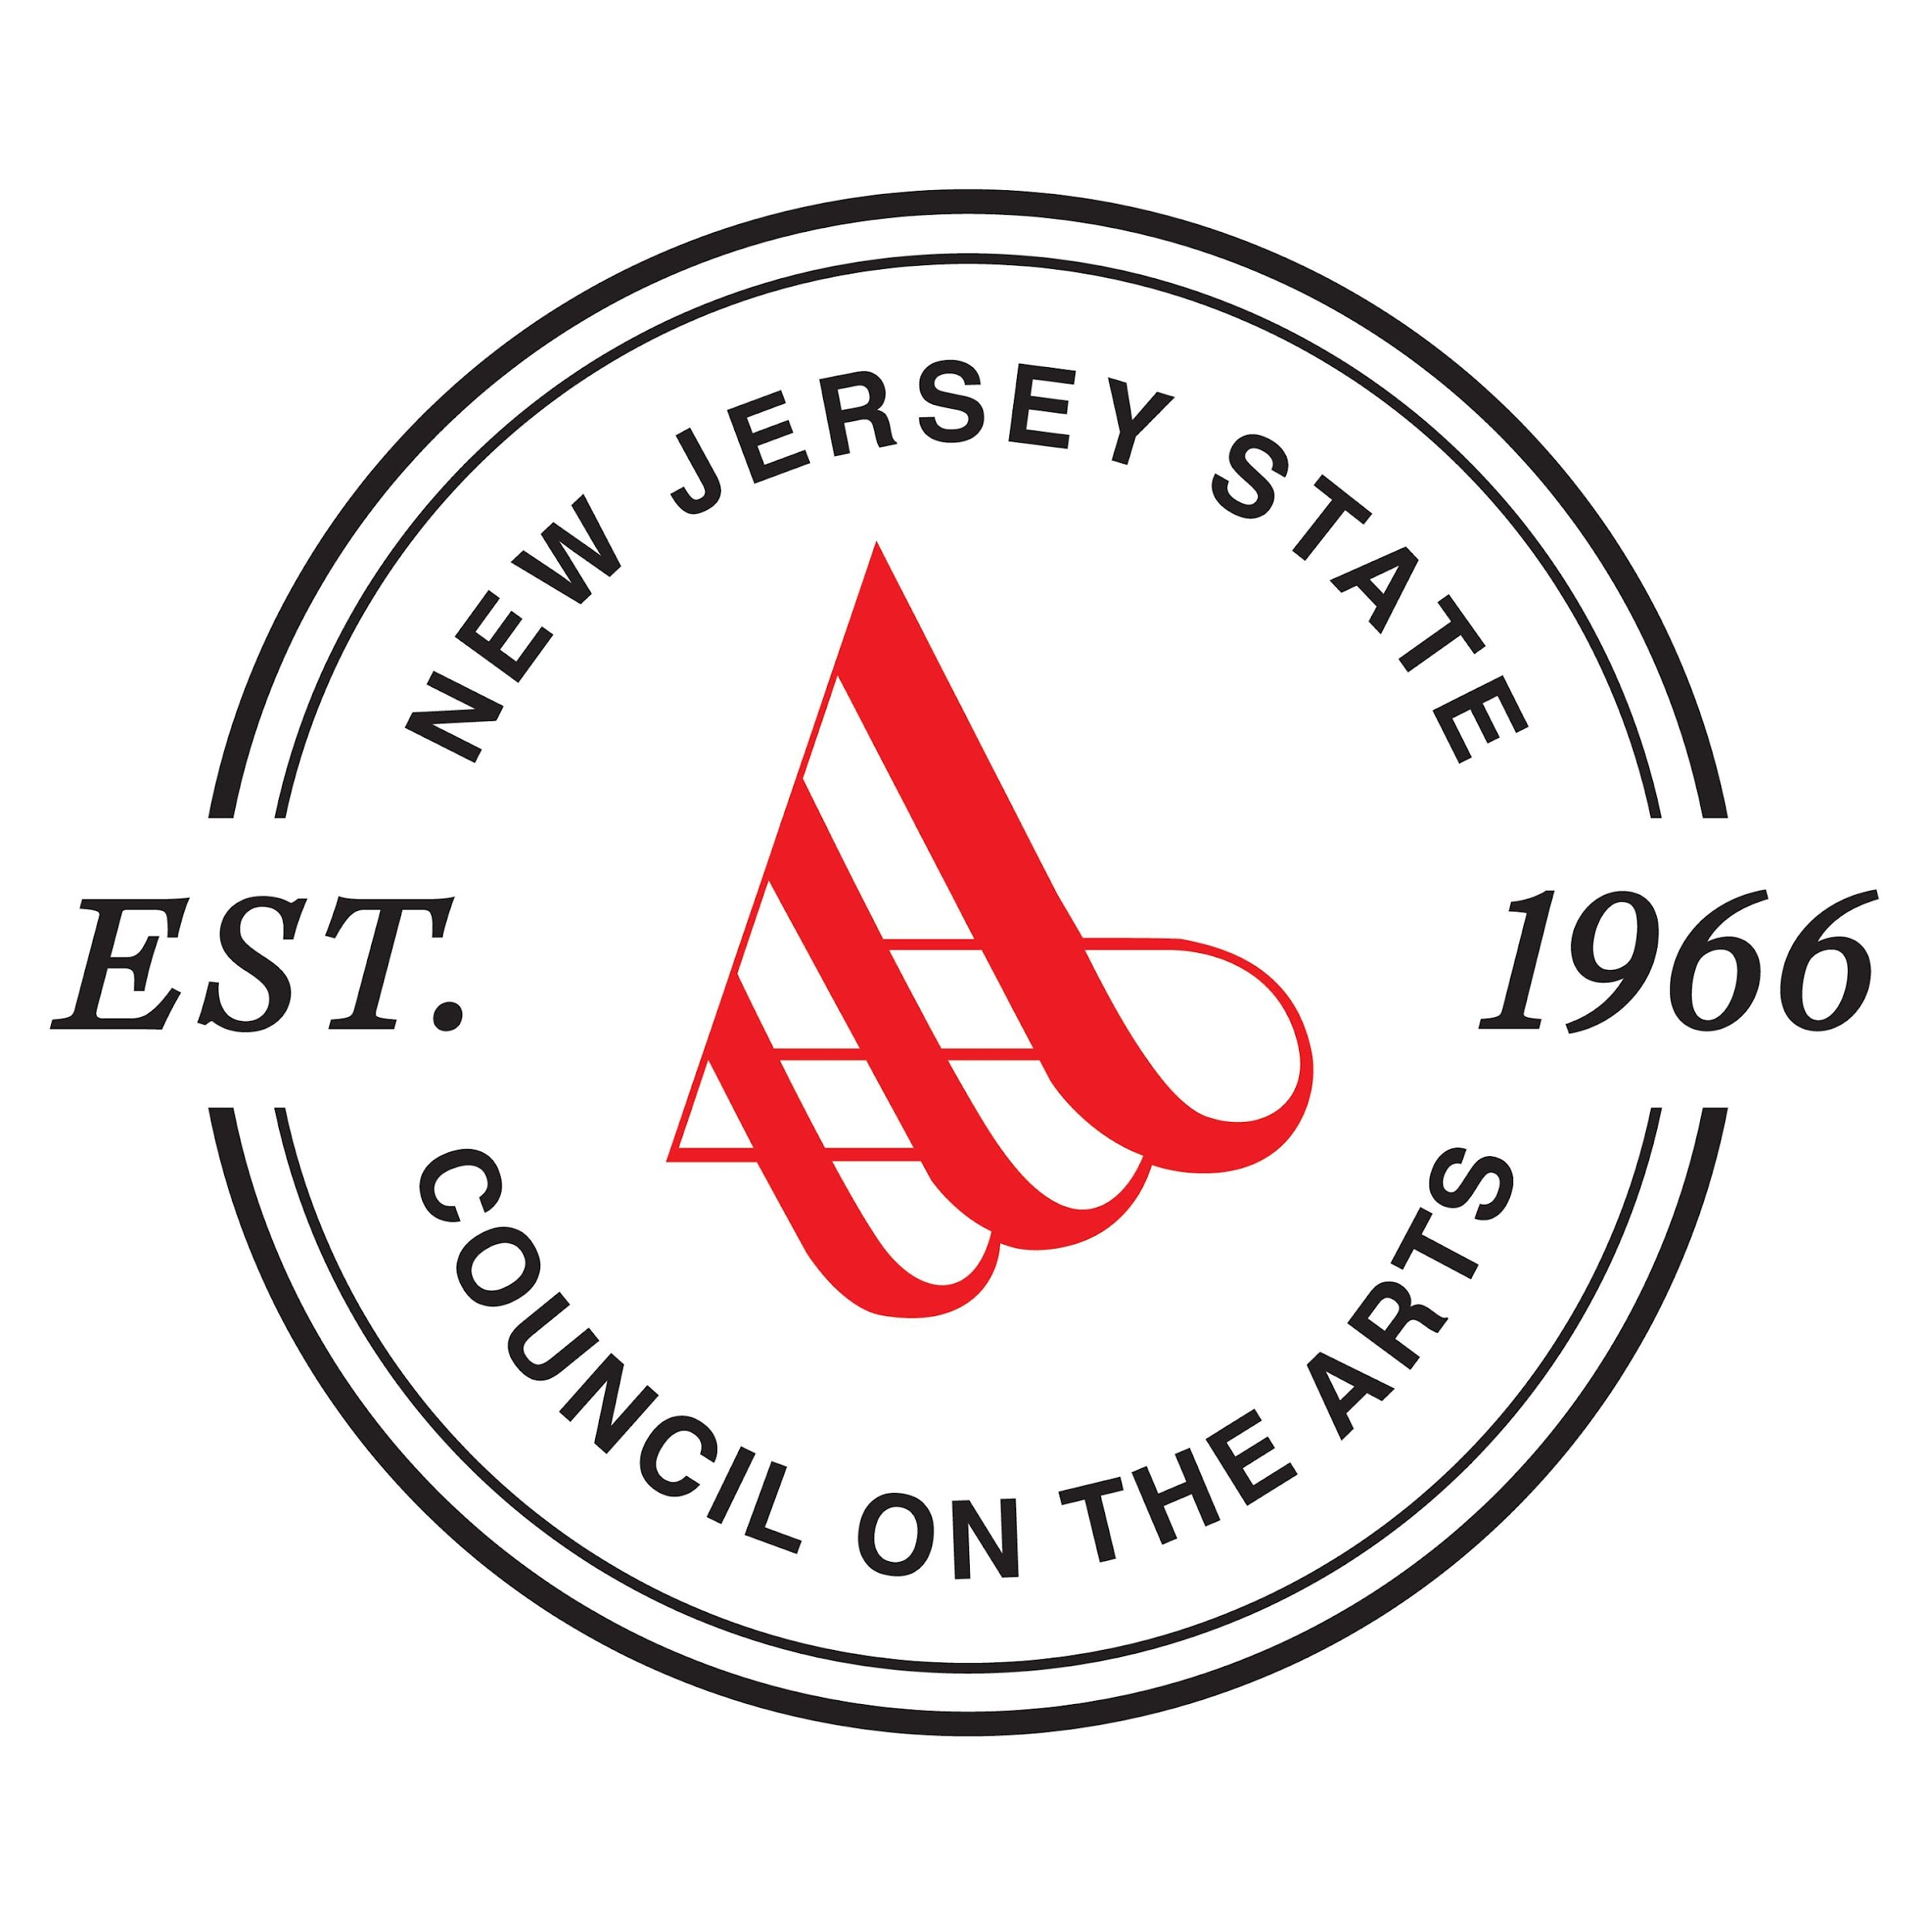

**APPENDIX II**

**ADA Planning Guide**

* An ADAPlan describes the best efforts of your organization to ensure accessibility in facilities, programming, governance, and marketing. It is recommended that a comprehensive self-assessment for an organization be completed to better understand its full obligations under the law. A Self-Assessment Survey tool developed by the Cultural Access Network of New Jersey is available at [www.culturalaccessnetwork.org/resources/](http://www.culturalaccessnetwork.org/resources/). Although designed for arts organizations, the guidelines are applicable to cultural facilities and programming generally. The plan should address the following items:
* Organizational Mission Statement: An ADA Plan should include a few paragraphs describing the organization’s background, mission and type of programming offered.
* Board-Approved ADA and Non-Discrimination Policy Statement: An ADA Plan should outline the attitudes, practices and policies which provide a conducive environment for inclusion of people with disabilities, including, but not limited to, employment/volunteer practices, interview processes, and accommodations for volunteers with special needs.
* Grievance Procedure: All non-profit organizations must develop their own Grievance Procedures. The purpose of a Grievance Procedure is to provide an internal mechanism for the prompt and equitable resolution of discrimination issues and complaints for employees, volunteers and **audience members**.
* Outline of Program and Services for People with Disabilities: The outline should include descriptions of current services and programs and those proposed to be implemented.
  + Do you conduct sensitivity training with your staff and volunteers on an annual basis?
  + Do you provide reduced ticketing charges for disabled audience members and non-disabled assistive companions?
* Outline of Marketing, Publication Services and other Outreach Efforts to People with Disabilities: The outline should include current and proposed outreach efforts.
  + Do you advertise through the County Department of Aging & Disabled?
  + Do your press releases and advertising mention accessibility and provide contact information for further information?
  + Do your fliers and brochures include standard accessibility logos?
* Outline of the Current Status of ADA Accessibility for All Venues to be Utilized:
  + Have you completed a self-assessment of your facility? If so, what were the findings?
  + Do you have ADA compliant parking with accessible spaces and drop off areas?
  + Do you have wheelchair accessible routes to all public spaces?
  + Do you have accessible bathrooms?
  + Do you have wheelchair seating?
  + Do you offer assistive listening devices to augment sound for people who are hearing impaired?