Gloucester County Cultural & Heritage Commission
N.J. Historical Commission Re-granting Program
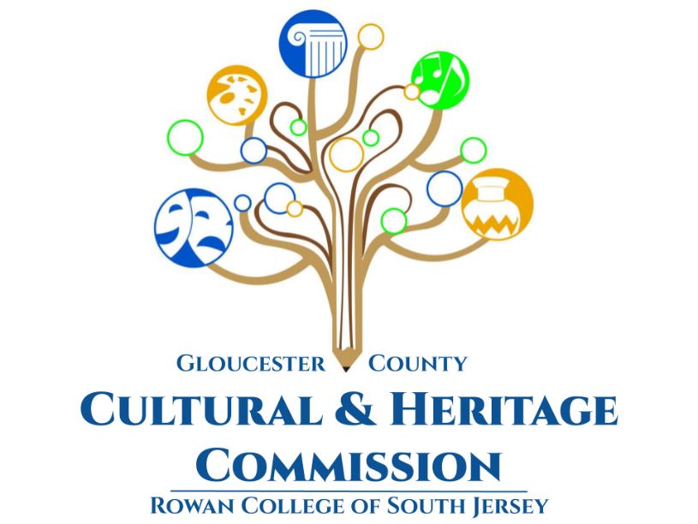

Guidelines and Application
for
Calendar Year January 1, 2027 – December 31, 2027

Submission Deadline: November 13, 2026

Gloucester County Cultural & Heritage Commission
(856) 562-7538
www.rcsj.edu/Cultural-site

Commissioners

Carlos Fernandez
Samuel Horowitz
Richard Hughes
Diane MacWilliams
Dr. Gina Mateka
Jim O’Connor

Marcela Savelski
Alan Willoughby
Open Position
Open Position
Open Position
Open Position

Staff
Erika Gardner egardner@rcsj.edu
Administrator, Cultural and Heritage Affairs
Judy MacKenzie jmacken1@rcsj.edu
Director, RTF Services

Table of Contents

Introduction Page 2
Eligible Organizations Page 2
Eligible Projects Page 3
Ineligible Expenses Page 3
Funding Levels Page 3
Matching Funds Requirements Page 4
Review Process Page 4
Awards Announcements Page 5
Payment Distribution Page 5
Acknowledgement Page 6
Sample Logos Page 6
Appeal Procedure Page 6
APPLICATION:
Application Checklist Page 7
Organization Information Page Page 8
Project Narrative Page 9
2027 Project Budget Page 10
Budget Narrative Page 11
Appendix I: ADA Planning Guide Page 12

Introduction

Thank you for your interest in the Gloucester County Cultural & Heritage Commission’s (GCC&HC) New Jersey Historical Commission (NJHC) County History Partnership Program (CHPP).

GCC&HC is the organization charged by the county to recommend and administer programs to increase the visibility and impact of local and county history, of the arts, and of the cultural values, goals and traditions of the community. It serves as an advisory agency to the Board of Chosen Freeholders and aids the Freeholders in seeking available State and Federal funds to develop and support historical, arts and cultural programs.

A significant part of the GCC&HC’s work each year is the development and administration of the CHPP Re-Grant provided by the New Jersey Historical Commission whose mission is to enrich the lives of the public by preserving the historical record and advancing interest in and awareness of New Jersey’s past.

The County History Partnership Program (CHPP) was created in 2015 to extend local re-granting programs to all of the state’s 21 counties. The program enables the NJHC to support both existing and emerging local history organizations and practitioners serving diverse audiences. Through the partnership with county re-granting agencies, NJHC support can more effectively reach history organizations and projects in communities throughout the state. A CHPP Re-Grant is a single proposal submitted to a single source to fund the projects and/or expenses of several organizations. The NJHC reviews the blocks, and based on the perceived quality of the proposed programming and the anticipated value to the community, they allocate funds from their annual budgets to the County. Using the same criteria, GCC&HC then regrants some or all of the funding requested to the individual groups for implementation of their programs.

Below you will find information to assist you in completing your application and support documents. If you need assistance, please contact Erika Gardner at the contact information listed on the cover page of the application.

Digital copies of the application are available on the GCCH&C website and by request. A complete application submission consists of one original (mailed or hand-delivered) and one digital copy (via email) including all supporting documents.

Eligible Organizations

Funding is open to any nonprofit, government, or educational agency to sponsor a special local history related project regardless of the intent of its charter. For example, a civic organization may present a historic lecture, or a social organization may research and publish a history brochure.

All proposals must comply with guidelines established by the funding entities and organizations must provide proof of non-profit, government, or educational status. All applicants must be in compliance with:
- Fair Labor Practices Law
- Civil Rights Act of 1964
- Rehabilitation Act of 1973 (as amended)
- American with Disabilities Act

Organizations may apply for one (1) history re-grant per year and all projects must take place within Gloucester County and be in some way related to Gloucester County’s history.

Applicants may not receive grants from both the Gloucester County Cultural and Heritage Commission and the New Jersey Historical Commission in the same funding cycle.

Failure of an applicant to supply requested information or comply with terms will result in disqualification.

Eligible Projects

Eligible projects must present the significance of the project and include evidence that the work has been, or will be, presented, reviewed and/or approved by persons professionally qualified to do so as defined in the National Park Service’s 36CFR 61, Appendix A:
“The minimum professional requirements in history are a graduate degree in history or closely related field or a bachelor's degree in history or closely related field plus one of the following:
The equivalent of at least two years of full-time experience in research, writing, teaching, interpretation, or other demonstrable professional activity with an academic institution, historical organization or agency, museum, or other professional institution; or
Substantial contribution through research and publication to the body of scholarly knowledge in the field of history.”
Projects can be presented in any of the following formats:
- Written history based on primary sources (NJ and/or National Register nominations; oral history projects; biographies, cultural histories, inventories or curatorial assessments that will provide a documentary record, etc..)
- Non-written public history (videos, group, self-guided, and/or podcast tours, websites, seminars, conferences, workshops, lectures, Historic American Building Survey work, documentary photography, etc.)
- Publications (printing of brochures or tour guides, information sharing websites, re-publication of historical materials, documentaries, etc.)
- “Artful history*” (murals, musical performances, historical re-enactments, living history presentations, etc.) *Please note that projects in the artful history category must maintain a historic focus. If you are unsure, please contact GCC&HC to determine if your project will better fit as an arts grant.

All projects must commence before December 31, 2027 for compliance with the NJHC grant cycle. GCC&HC will individually evaluate projects that do not fit within this period.

Ineligible Expenses

Funds may NOT be used for the following:
- Capital expenses or equipment (any material with a three years or longer life expectancy. Exceptions include specific materials such as sheet music or project specific materials.)
- Deficit reduction or replacement of funds normally budgeted for agency activities
- Food, beverages, or other entertaining costs.
- Scholarships or prizes

Funding Levels

There are no monetary limits on the amount of funding that may be requested. However, it is important to understand that grants are competitive, and the final awards are based on merit, including the completeness and correctness of the application, documentation of past programming, financial and administrative capability, the quality of the project, and prior funding histories, if available.

We ask, therefore, that applicants use good judgment when completing the budget information. Inflated budgets will be flagged, and may adversely affect funding decisions at all levels of review. Applicants are encouraged to submit budgets that accurately reflect their needs. Although the Commission always has more requests than funds, every effort will be made to award appropriate funding. Please do not hesitate to request more funding if your project truly requires it, and you can justify the expenses. It is not our intent to restrict your vision, but rather to encourage fiscal responsibility.

In turn, funding decisions are not made with minimum/maximum award limits. The Grants Review Panel may recommend reduced funding because of procedural failings or because the panel feels that the amount requested cannot be justified by the scope of the project, but it will not reduce the amount of a request simply to fall under an artificially constructed dollar limit.

Matching Funds Requirements

Each organization is encouraged but not required to match the funding requested from the GCC&HC’s re-grant program on a 1:1 basis (colleges and universities match on a 2:1 ratio). That is, for each dollar you request, you are able to provide a dollar from other funding sources. Additional funding sources may include cash from government agencies (excluding the NJHC and NJSCA), private contributions, membership fees, admission to programs, and other grants, etc. Salaries and benefits for employees of the organization may be considered part of your optional match only for that part of their job that is related to the project in question. Additional in-kind donations may count towards your optional match.

Requirements for Acknowledgements

The following language and logos must be used in all promotional items and/or publications (posters, flyers, programs, etc.): “This program is made possible by funds from the New Jersey Historical Commission/Department of State and the Gloucester County Cultural and Heritage Commission.”

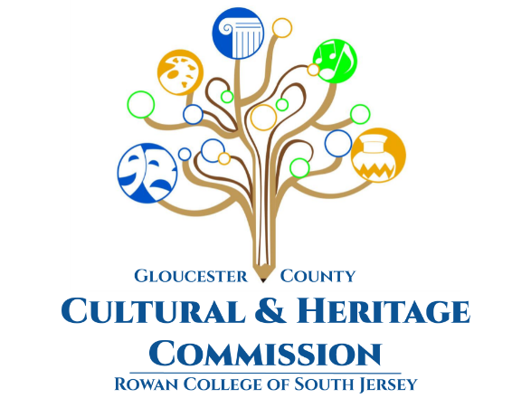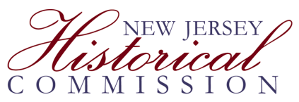

Properly formatted logo options will be available digitally upon funding. One version of each logo must appear on all promotional items and/or publications.

Review Process

At the beginning of each grant cycle, a Grant Writing Workshop is held to provide applicant organizations the opportunity to meet with GCC&HC staff, review the requirements for the proposal, and ask questions and explore ideas for qualifying projects. All organizations planning to submit a proposal are encouraged to send a representative to the meeting, preferably the person responsible for organizing the proposal and writing the narrative. First time applicants are required to complete a Notice of Intent (NOI) and an NOI is strongly suggested for all applicants.

Once the final application submission is made, the Executive Director checks to determine that all required information is included and then prepares review packets for the Grants Review Panel. This independent panel of arts and history professionals carefully reviews all applications received for the grant cycle. The proposals are evaluated for merit and the manner in which the proposals address the needs of the community, compliance with local, state and federal law, the applicant’s administrative capabilities and prior program and funding history, where available. The Panel’s recommendations are then submitted to the Commission regarding which proposals should be funded and at what level. The Commission reviews the recommendations and submits their report to the RCGC Board of Trustees for final approval. At any point in this process questions may be referred back to the review panel.

The panel will make recommendations and provide scores to the Commission based on the following criteria:
- Quality of History, Education, or Creative Experience: Does the organization have a system or plan to ensure the highest quality work? Is the organization listening to numerous interests and points of perspective? Is the work or organization engaging and thought-provoking? How innovative is the concept?
- Audience Engagement: Are the experiences active, immersive, and social? How well does the organization understand and know its audience? Is there a participatory component? Is there a learning component? Is the experience more than a singular event and includes ways of continuing interaction and impact?
- Attendance/Quantitative Impact: How many individuals will this programming engage? Are there plans to reach as many people as possible? Is the marketing inclusive (i.e. are there efforts to reach a diverse audience)?
- Governance: Does the organization have a track record of good programming administration? Is the governance representative of the community being served, diverse, and/or inclusive? Are high standards of professional conduct in place? Does the institution conduct critical assessment to determine success and impact?
- Budget: Does the organization have a realistic grasp of the programming costs? Is the organization working to diversify funding sources across government, foundation, business and audience/member giving? Is efficiency a consideration in programming goals?

Awards Announcements

Announcements will be made by email and USPS mail in March 2027. Applicants should not begin projects dependent on re-grant funds until they have received official notification of an award amount. Every effort will be made to determine the likelihood of funding based on the best information available at the time, but no guarantee of funding can be made until the results are officially announced.

Payment Distribution

Grant funds are distributed in two payments. The first payment of 75% of your total award amount will be made in April 2027, after the terms and specifications of the award are met and contracts are signed. This process includes notification of the final amount of the award. You must allocate the funds that will be available at that time, and advise us of any changes that will be necessary to programs if there were reductions in your final award amount.

The second payment is made after the Final Report is submitted. Receipt of the final payment is dependent on several factors:

- Programs must be completed and funds utilized in strict compliance with the plans outlined in the proposal;
- Any changes in the program must be reported in the Final Report, and must have been discussed with GCC&HC staff prior to implementation;
- A Final Report must be on file at the GCC&HC office;
- The GCC&HC and the NJHC must have been credited in all advertising and published programs;
- The organization must have provided and documented the required cash matching funds.

All or part of the final payment may be withheld if the above conditions are not met, or if other requirements that may be stipulated by the GCC&HC or NJHC during the contract period are not met. The extent of the monies that are withheld will be based on the individual circumstances.

Appeal Procedure

Applicants may appeal the decision of the Commission upon receipt of the Panel’s determination letter. Please note: Appeals can be made only on the grounds that the application was misinterpreted or misunderstood. No appeal will be heard based solely on disagreements with the recommended funding level. No new information will be accepted for consideration, and additional segments cannot be added to increase the funding. Applicants will have two weeks from receipt of the determination letter to file an appeal with the Commission.

Gloucester County Cultural and Heritage Commission
County History Partnership Program Grant Application Checklist

This checklist represents the order in which your application should be packaged. A complete submission consists of ONE ORIGINAL copy, mailed or hand delivered, and ONE DIGITAL copy - emailed, of all the items on this checklist. ALL APPLICATIONS MUST BE SUBMITTED BY NOVEMBER 13, 2026.

- Organization Information page

- Application Narrative pages (no more than three (3) pages in total)

- Project Budget

- Budget Narrative (no more than one (1) page in total)

- Resumes of Project Personnel (This includes consultants, speakers, and other professionals who will be hired with grant funds.) (See Question 4)

- List of Board Members with terms and length of service including your State required “Cultural Code”*

- Copy of audit or financial review. At a minimum, for non-government non-profits this must include the organization’s most recent IRS Form 990.
  - For organizations whose annual gross income is less than $250,000, an internally produced, complete financial statement is sufficient to meet this standard.
  - For organizations whose annual gross income is $250,000 to $500,000, a review by a certified public accountant is sufficient to meet this standard.
  - For organizations whose annual gross income exceeds $500,000, please submit a complete annual financial statement audited in accordance with generally accepted auditing standards.

- Copy of Board approved ADA Plan or ADA self-assessment, if available. (See Appendix 1)

- Examples of past programming including acknowledgement of credit (press clippings, flyers, online advertising, etc. – limit of 3) (See Question 8)

Signature _______________________________________ Date ___________________
Name Title

Organization ____________________________________ Phone __________________

*Choose the Cultural Code that is the best representation of the predominant composition of your board and/or staff. If the project itself is targeted at a special constituency to promote cultural diversity then it must be noted in the narrative. (Please Circle)
Cultural Codes: A Asian B African-American
H Hispanic N Native American / Alaska Native
W White, not Hispanic P Native Hawaiian / Pacific Islander
G General (no single race represents more than 50%)

Organization Information

THE DEADLINE FOR ALL APPLICATIONS IS: FRIDAY, November 13, 2026
Applicant Organization: ______________________________________________________________
Address: ___________________________________________________________________________
Phone: ___________________ Fax: _____________________ Email: _________________________
Contact Person and Phone Number: _____________________ Website: _______________________
Federal ID No. ____________________________ Tax Exemption No. _________________________
State Legislative District: ___________________ ** NJ Charities Registration # ________________
**NJ non-profits who raise more than $10k/year must register with the Division of Consumer Affairs.

Type of organization: (please circle all that apply)
Historical Society Public Library/Archives Other School
Museum Private Library/Archives Municipal Government
Historic Site College/University Other Government

Year established __________
Accredited by the American Alliance of Museums (AAM)? ______
Accredited by other organizations? (please list)_____________________

Number of full-time paid staff: Number of part-time paid staff:
Number of volunteers: Number of board members:
Number of history programs held in 2026: Number of history program attendees in 2026:
Number of website visitors in 2026: Number of in-house visitors
Number of children served [K-12]:

Does your organization require membership?
If yes, how many members do you currently have?
What are your membership requirements and your fees?

Hours of operation and/or number of hours open annually:

Program Summary: (max: 150 words) _________________________________________________________________________________
____________________________________________________________________________________________________________________________________________________________________
Project Budget Summary:
GCC&HC Re-grant Amount Requested $ ___________________________
Cash Match $ ___________________________

__________________________________________________________________________________________
Name & Title of Representative Signature Date

History Grant Application
SPECIAL PROJECT NARRATIVE
APPLICANT ORGANIZATION

Please answer the following questions in the boxes provided using Times New Roman 12 pt. The GCC&HC Grants Review Panel will use the information provided herein to form its opinion of the value of the project and the appropriate funding level. Please provide enough detailed information to help the panel fully understand your project and your organization’s ability to carry it out. Do not exceed three (3) pages total.

1. Provide the mission statement and a brief history of your organization. Describe how history programming fits within your mission including descriptions of relevant projects/programs undertaken in the past 12 months.

2. Describe, in detail, your project, its goals, activities and content. Include where the project will take place.

3. Explain why this project is important. Include how the project is relevant to the history of Gloucester County.

4. Provide a summary of key project personnel including any presenters, consultants, etc. and their qualifications. If specific personnel are not yet selected, explain how project personnel will be recruited. (Attach full resumes or biographies separately.)

5. Provide an estimated timeline for your project. Include time frames for planning, publicity, and evaluative components. If projects cannot be completed in person, please list your plan for a virtual option.
Month | Activity

6. Describe your intended target audience including how many people you expect to serve, how the project will benefit the community, and how the project will br4\/aden, deepen, and/or diversify your organization.

7. What is your anticipated demographic composition, and how special constituencies will be accommodated. If possible, provide information on strategies that have been successful for you in the past. (If an ADA plan or self-assessment is available, please attach separately.)

8. Beyond attendance, describe how you will determine if your project is a success for your organization; for your community. Include methods of evaluation that will be used and how you plan to interpret that data.

9. Describe your detailed publicity plan. Be specific about how and where you will use logos and credit lines. (Please include up to three (3) examples of past publicity.)

10. Will your project involve any partnerships or collaborations? If yes, describe with who and how they will benefit the project as a whole.

2027 PROJECT BUDGET

 | GCC&HC Grant Funds | Organization Cash Match | Other Cash Match | In-Kind** | TOTAL
EXPENSE ITEM
Administrative Salary
Other Salary
Technical/Production Salary
Fringe Benefits
Other Professional Services
Space/Equipment Rental
Marketing/advertising/PR
Travel/Transportation
Phone/Postage
Printing
Insurance
Supplies/Materials
Hospitality
Other Expenditure (list)
EXPENDITURE TOTAL:
ORGANIZATION MATCH
Cash Reserves
Fundraising Activities
Merchandise, Concession, and/or Ad Sales
Admission/Ticket Sales
Endowment/Interest Income
Private Contributions
Other Income (list)
MATCH TOTAL*:

*The 1-1 match is not a requirement.
**An In-Kind match of 50% of your grant request is suggested.
BUDGET NARRATIVE (limit to 1 page)
Provide a breakdown for how funds will be spent including detailed itemization, where available, on hourly costs, per-piece prices, etc. (Example: Dr. Jane Doe - 2 hour history lecture @$125/hour; 1000 color brochures @.50/each, etc.) Explain the origin of donated in-kind items and services as well as any listed “cash from other sources” and if those amounts are projected or actual.

APPENDIX I

ADA Planning Guide

- An ADA Plan describes the best efforts of your organization to ensure accessibility in facilities, programming, governance, and marketing. It is recommended that a comprehensive self-assessment for an organization be completed to better understand its full obligations under the law. A Self-Assessment Survey tool developed by the Cultural Access Network of New Jersey is available at https://njtheatrealliance.org/accessibility/self-assessment. Although designed for arts organizations, the guidelines are applicable to cultural and heritage facilities and programming generally. The plan should address the following items:

- Organizational Mission Statement: An ADA Plan should include a few paragraphs describing the organization’s background, mission and type of programming offered.

- Board-Approved ADA and Non-Discrimination Policy Statement: An ADA Plan should outline the attitudes, practices and policies, which provide a conducive environment for inclusion of people with disabilities, including, but not limited to, employment/volunteer practices, interview processes, and accommodations for volunteers with special needs.

- Grievance Procedure: All non-profit organizations must develop their own Grievance Procedures. The purpose of a Grievance Procedure is to provide an internal mechanism for the prompt and equitable resolution of discrimination issues and complaints for employees, volunteers and audience members.

- Outline of Program and Services for People with Disabilities: The outline should include descriptions of current services and programs and those proposed to be implemented.
  - Do you conduct sensitivity training with your staff and volunteers on an annual basis?
  - Do you provide reduced ticketing charges for disabled audience members and non-disabled assistive companions?

- Outline of Marketing, Publication Services and other Outreach Efforts to People with Disabilities: The outline should include current and proposed outreach efforts.
  - Do you advertise through the County Department of Aging & Disabled?
  - Do your press releases and advertising mention accessibility and provide contact information for further information?
  - Do your fliers and brochures include standard accessibility logos?

- Outline of the Current Status of ADA Accessibility for All Venues to be Utilized:
  - Have you completed a self-assessment of your facility? If so, what were the findings?
  - Do you have ADA compliant parking with accessible spaces and drop off areas?
  - Do you have wheelchair accessible routes to all public spaces?
  - Do you have accessible bathrooms?
  - Do you have wheelchair seating?
  - Do you offer assistive listening devices to augment sound for people who are hearing impaired?

